Title or Task: |   

Description:

Files Required
Suitable for Classes: | AIT • Multimedia • Cert II IT • Cert II Bus
Area: | Technology & Enterprise
Teacher: | Mr Peter Faulks

Timeline

Date Due:
Task Brief: | In class lesson

Outcomes:

Items highlighted in yellow are tasks for you to complete
Items in Blue italics are help tips

These pages are designed to show you how to use software packages; various software updates may have taken place so some pages will not apply to versions other than those listed here. In some cases data files may be required.

Famous People
Add images and sort into chronological sequence

Ensure that you save this for reference when writing resumes or essays etc.

Captain Roald Engelbregt Gravning Amundsen, (born July 16, 1872, Borge, near Oslo, Norway—died June 18, 1928?), Arctic OceanBritish explorer Robert Falcon Scott and Norwegian explorer Roald Amundsen went head to head to be the first to reach the South Pole reached the South Pole in 1912. He was the first man in history to sail the treacherous Northwest Passage linking the Atlantic and Pacific Oceans.British explorer Robert Falcon Scott and Norwegian explorer Roald Amundsen went head to head to be the first to reach the South Pole reached the South Pole in 1912. He was the first man in history to sail the treacherous Northwest Passage linking the Atlantic and Pacific Oceans. Disappeared 18 June 1928

William Baffin1584 – 23 January 1622He is primarily known for his attempt to discover a Northwest Passage from the Atlantic to the Pacific, during the course of which he was the first European to discover Baffin Bay in present-day Canada.

Vasco Nunez de Balboa1475 - died January 12, 1519Was a Spanish explorer, governor, and conquistador. He is best known for having crossed the Isthmus of Panama to the Pacific Ocean in 1513, becoming the first European to lead an expedition to have seen or reached the Pacific from the New World discovered The Pacific Ocean

Jeanne Barret July 27, 1740 – August 5, 1807Jeanne Baret didn't set out to be the first woman to circumnavigate the globe. When she stepped onboard the Etoile in 1766, dressed as a man, she was looking for plants.

Sir Samuel White Barker June 8, 1821 - died London 18933English explorer who, with John Hanning Speke, helped to locate the sources of the Nile River. Discovered Lake Albert Nyanza, Two months later at Gondokoro he met Speke and Grant, who, after led by the local Africans to the source of the Nile, were following the river to Egypt. Their success made him fear that there was nothing left for his own expedition to accomplish; but the two explorers gave him information which enabled him, after separating from them, to achieve the first European visit to Albert Nyanza (Lake Albert), of whose existence credible assurance had already been given to Speke and Grant. Baker first sighted the lake on 14 March 1864. After some time spent in the exploration of the neighbourhood, Baker demonstrated that the Nile flowed through the Albert Nyanza. He formed an exaggerated idea of the relative importance of the Albert and Victoria lake sources in contributing to the Nile flow rate.

Battuta Ibn 24 February 1304 – 1368 or 1369Over a period of thirty years, Ibn Battuta visited most of the Islamic world and many non-Muslim lands, including Central Asia, Southeast Asia, India and China

Vitus Jonassen Bering (5 August 1681, died 19 December 1741), also known as Ivan Ivanovich Bering, was a Danish cartographer and explorer in Russian service, and an officer in the Russian Navy. Navigator whose exploration of the Bering Strait and Alaska prepared the way for a Russian foothold on the North American continent. He is known as a leader of two Russian expeditions, namely the First Kamchatka Expedition and the Great Northern Expedition, exploring the north-eastern coast of the Asian continent and from there the western coast on the North American continent. The Bering Strait, the Bering Sea,Bering Island, the Bering Glacier and the Bering Land Bridge were all named in his honor.

Rear Admiral Richard Evelyn Byrd October 25, 1888, Winchester, Virginia, U.S.—died March 11, 1957A U.S. naval officer, pioneer aviator, and polar explorer best known for his explorations of Antarctica using airplanes and other modern technical resources.He flew over the North Pole in 1926; flew over the South Pole in 1929

Sebastian Cabotb.1474 d. December 1557 (aged c. 83)Labrador in 1497, Cabot sailed for both England and Spain to explore possible Northwest and Northeast Passages and was one of the earliest explorers to map North and South America and surrounding territories.

Captain James Cook 7 November 1728 - died 14 February 1779The Sandwich Isles, navigator and explorer who, in 1770, discovered and charted New Zealand and the Great Barrier Reef of Australia on his ship HMB Endeavour. He later disproved the existence of Terra Australis, a fabled southern continent.

Jacques Cartier December 31, 1491 - died 1 September 1557Explored a great deal of Canada, especially the Gulf of St. Lawrence and the river St. Lawrence. French navigator Jacques Cartier was sent by King Francis I to the New World in search of riches and a new route to Asia in 1534. His exploration of the St. Lawrence River allowed France to lay claim to lands that would become Canada.

Christopher Columbus 1451, Genoa, Italy - died: 20 May 1506 America, and the West Indies San Salvador, He led the first European expeditions to the Caribbean, Central America, and South America, initiating the permanent European colonization of the Americas.

John Davis 1550 – died 29 December 1605Discovered Davis Strait. John Davis was one of the chief navigators of Queen Elizabeth I of England. He led several voyages to discover the Northwest Passage and served as pilot and captain on both Dutch and English voyages to the East Indies. He discovered the Falkland Islands in August 1592.

Sir Francis Drake 1540 – died 28 January 1596was the first person to sail around the world, 1577-1580. Sir Francis Drake is best known for circumnavigating Earth (1577–80), preying on Spanish ships along the way. Later he was credited for his defense of England by raiding Spain's harbour at Cádiz in 1587 and (according to many sources) by disrupting the Spanish Armada in the English Channel with fire ships in 1588.

Matthew Flinders 16 March 1774 – 19 July 1814Was an English navigator and cartographer who led the second circumnavigation of New Holland that he would subsequently call "Australia or Terra Australis" and identified it as a continent, also discovered Bass Strait.

Sir Martin Frobisher 1535 – 22 November 1594Was an English explorer who became a licensed pirate and plundered French ships off the coast of Africa. In the 1570s, he made three voyages to discover a Northwest Passage. Instead, he discovered Labrador and discovered Frobisher's Strait and what is now Frobisher Bay.

Vasco Da Gama 1460s – 24 December 1524The sea route to India 1498, was a Portuguese explorer and the first European to reach India by sea. His initial voyage to India (1497–1499) was the first to link Europe and Asia by an ocean route, connecting the Atlantic and the Indian oceans and therefore, the West and the Orient.

Sir Humphrey Gilbert 1539 – 9 September 1583Elizabethan explorer who annexed Newfoundland to England Sir Humphrey Gilbert (1539-1583) was an English nobleman, Army officer, member of Parliament, and explorer.
He sailed to North America in search of a Northwest Passage (a sea route to Asia through North America). He founded an English settlement in Newfoundland.
Gilbert is said to have believed that America was the lost continent of Atlantis (a legendary but fictional continent that is said to have sunk in ancient times). He was determined to find a sea route through the northern waters of North America. On September 23, 1578, he sailed from England, but was attacked by Spaniards and returned to England.
He successfully sailed again on June 11, 1583, with 5 ships. One ship had to return because of leaks, but the others eventually made it to North America. He landed in Newfoundland on July 30, 1583, and then sailed to St. John's. Gilbert claimed the area for Queen Elizabeth I of England, and started a colony.
After two weeks in his new colony, Gilbert left his colony to explore the area around Nova Scotia. He died on this expedition when his boat, the "Squirrel," sank near the Azore Islands on September 9, 1583 (he was returning to England). Gilbert was the step-brother of Sir Walter Raleigh.

Henry, the Navigator 4 March 1394 – 13 November 14Madeira and the Azores, better known as Prince Henry the Navigator, was a central figure in the early days of the Portuguese Empire and in the 15th-century European maritime discoveries and maritime expansion.During Prince Henry's time and after, the Portuguese navigators discovered and perfected the North Atlantic Volta do Mar (the "turn of the sea" or "return from the sea"): the dependable pattern of trade winds blowing largely from the east near the equator and the returning westerlies in the mid-Atlantic. This was a major step in thehistory of navigation, when an understanding of oceanic wind patterns was crucial to Atlantic navigation, from Africa and the open ocean to Europe, and enabled the main route between the New World and Europe in the North Atlantic in future voyages of discovery.

Henry Hudson 1570 – disappeared 23 June 1611Hudson River, Hudson Strait, Hudson Bay, English, Henry Hudson set sail on a ship called Discovery. He discovered a strait in the ocean that led them through the northern waters over Canada, which was later named the Hudson Strait. Henry and his crew sailed through the strait and into a large bay. It later became known as Hudson's Bay. The crew of mutineers cast Hudson, his son, and seven others adrift; the Hudsons and their companions were never seen again.

David Livingstone (b 19 March 1813 – 1 May 1873) was a Scottish physician, Congregationalist, and pioneer Christian missionary with the London Missionary Society, an explorer in Africa, and one of the most popular British heroes of the late 19th-century Victorian era. Was a Scottish missionary, abolitionist and physician known for his explorations of Africa, having crossed the continent during the mid-19th century, explored a great deal of Africa.

Ferdinand Magellan1480-1521Portuguese explorer Ferdinand Magellan set out from Spain in 1519 with a fleet of five ships to discover a western sea route to the Spice Islands. En route he discovered what is now known as the Strait of Magellan and became the first European to cross the Pacific Ocean. He was the first person to attempt to sail around the world. he was eventually selected by King Charles I of Spain to search for a westward route to the Maluku Islands (the "Spice Islands"). Commanding a fleet of five vessels, he headed south through the Atlantic Ocean to Patagonia. Despite a series of storms and mutinies, they made it through the Strait of Magellan into a body of water he named the "peaceful sea" (the modern Pacific Ocean).[3] The expedition reached the Philippine islands, where Magellan was killed during the Battle of Mactan. The expedition later reached the Spice Islands in 1521 and one of the surviving ships eventually returned home via the Indian Ocean, completing the first circuit of the globe.

Victoria, the sole ship of Magellan's fleet to complete the circumnavigation.

Marco Polo 1254 – died January 9, Venice, 1324He made explorations in China, India and the East, he was a Venetian explorer known for the book The Travels of Marco Polo, which describes his voyage to and experiences in Asia. Polo traveled extensively with his family, journeying from Europe to Asia from 1271 to 1295 and remaining in China for 17 of those years.

Rear Admiral Robert Edwin PearyU.S. 6 May 1856, Cresson, PennsylvaArctic explorer usually credited with leading the first expedition to reach the North Pole, succeeded in reaching the North Pole on 6th April, 1909.

Captain Robert Scott 6 June 1868 – c. 29 March 1912British explorer Robert Falcon Scott reached the South Pole, January 18th, 1912 famously took part in the race to claim the South Pole in 1911, but sadly failed in his mission and died on his return journey.

Sir Ernest Shackleton 5 February 1874 – 5 January 1922Reached within 100 miles of the South Pole was an explorer who in 1901 joined an expedition to the Antarctic. He was sent home early due to bad health. Devoted to creating a legacy, he led the Trans-Antarctic Expedition. Disaster struck when his ship, the Endurance, was crushed by ice.

Amerigo Vespucci March 9, 1454 – February 22, 1512Discovered North & South America 1501 a portion of Brazil that Vespucci had explored was named "America," the name "America" was applied to both the northern and southern landmasses of the New World, America is named after Amerigo Vespucci, the Italian explorer who set forth the then revolutionary concept that the lands that Christopher Columbus sailed to in 1492 were part of a separate continent. ... He included on the map data gathered by Vespucci during his voyages of 1501-1502 to the New World.

History of Discovery Australia

The history of Australia is the history of the area and people of the Commonwealth of Australia with its preceding Indigenous and colonial societies. Aboriginal Australians arrived on the Australian mainland by sea from Maritime Southeast Asia between 40,000 and 70,000 years ago. The artistic, musical and spiritual traditions they established are among the longest surviving such traditions in human history.

The first known landing in Australia by Europeans was by Dutch navigator Willem Janszoon in 1606. Later that year, Spanish explorer Luís Vaz de Torres sailed through, and navigated, Torres Strait islands.[1] Twenty-nine other Dutch navigators explored the western and southern coasts in the 17th century and dubbed the continent New Holland. Macassan trepangers visited Australia's northern coasts after 1720, possibly earlier. Other European explorers followed until, in 1770, Lieutenant James Cook charted the east coast of Australia for Great Britain and returned with accounts favouring colonization at Botany Bay (now in Sydney), New South Wales.

AUSTRALIA

1606 Willem Janszoon (Dutch c. 1570 – c. 1630), sometimes abbreviated to Willem Jansz., was a Dutch navigator and colonial governor. Janszoon served in the Netherlands East Indies in the periods 1603–1611 and 1612–1616, including as governor of Fort Henricus on the island of Solor.[2] He is the first European known to have seen the coast of Australia during his voyage of 1605–1606.

1606 Luís Vaz de Torres (Portuguese), (born c. 1565; fl. 1607), was a 16th- and 17th-century maritime explorer of a Spanish expedition noted for the first recorded European navigation of the strait which separates the mainland of Australia from the island of New Guinea, and which now bears his name (Torres Strait).

1616 Dirk Hartog (Dutch b. 30 October 1580 – buried 11 October 1621) was a 17th-century Dutch sailor and explorer. Dirk Hartog's expedition was the second European group to land in Australia and the first to leave behind an artefact to record his visit, the Hartog plate. His name is sometimes alternatively spelled Dirck Hartog or Dierick Hartochszch

1619 Frederick de Houtman (c. 1571 – 21 October 1627) was a Dutch explorer, navigator, and colonial governor who sailed on the first Dutch expedition to the East Indies from 1595 until 1597, In 1619 De Houtman sailed in the Dutch East India Company ship Dordrecht, along with Jacob Dedel in the Amsterdam. They sighted the Australian coast near present-day Perth, which they called Dedelsland. After sailing northwards along the coast he encountered and only narrowly avoided a group of shoals, subsequently called the Houtman Abrolhos.
1642 Abel Janszoon Tasman (Dutch b. 1603 – 10 October 1659) was a Dutch seafarer, explorer, and merchant, best known for his voyages of 1642 and 1644 in the service of the Dutch East India Company (VOC). He was the first known European explorer to reach the islands of Van Diemen's Land (now Tasmania) and New Zealand, and to sight the Fiji islands.

1696 Willem de Vlamingh was born in Oost-Vlieland in the Dutch Republic on 28 November 1640. In 1664, De Vlamingh sailed to Novaya Zemlya and discovered Jelmerland.
On 29 December 1696, De Vlamingh's party landed on Rottnest Island. He saw numerous quokkas (a native marsupial), and thinking they were large rats he named it 't Eylandt 't Rottenest ("Rats' Nest Island"). He afterwards wrote of it in his journal: "I had great pleasure in admiring this island, which is very attractive, and where it seems to me that nature has denied nothing to make it pleasurable beyond all islands I have ever seen, being very well provided for man's well-being, with timber, stone, and lime for building him houses, only lacking ploughmen to fill these fine plains. There is plentiful salt, and the coast is full of fish. Birds make themselves heard with pleasant song in these scented groves. So I believe that of the many people who seek to make themselves happy, there are many who would scorn the fortunes of our country for the choice of this one here, which would seem a paradise on earth

1699 William Dampier (b 5 September 1651; died March 1715) was an English explorer, ex-pirate and navigator who became the first Englishman to explore parts of what is today Australia, and the first person to circumnavigate the world three times. He has also been described as Australia's first natural historian, as well as one of the most important British explorers of the period between Sir Walter Raleigh and James Cook.
On 5 January 1688, Cygnet "anchored two miles from shore in 29 fathoms" on the northwest coast of Australia, near King Sound. Dampier and his ship remained there until March 12, and while the ship was being careened Dampier made notes on the fauna and flora and the indigenous peoples he found there. Later that year, by agreement, Dampier and two shipmates were marooned on one of the Nicobar Islands. They obtained a small canoe which they modified after first capsizing and then, after surviving a great storm at sea, called at "Acheen" (Aceh) in Sumatra.
Dampier returned to England in 1691 via the Cape of Good Hope, penniless but in possession of his journals.

1770 James Cook FRS (7 November 1728 – 14 February 1779) was a British explorer, navigator, cartographer, and captain in the British Royal Navy. He made detailed maps of Newfoundland prior to making three voyages to the Pacific Ocean, during which he achieved the first recorded European contact with the eastern coastline of Australia and the Hawaiian Islands, and the first recorded circumnavigation of New Zealand. The expedition sailed aboard HMS Endeavour, departing England on 26 August 1768. Cook and his crew rounded Cape Horn and continued westward across the Pacific, arriving at Tahiti on 13 April 1769, where the observations of the Venus Transit were made. However, the result of the observations was not as conclusive or accurate as had been hoped. Once the observations were completed, Cook opened the sealed orders, which were additional instructions from the Admiralty for the second part of his voyage: to search the south Pacific for signs of the postulated rich southern continent of Terra Australis. Cook then sailed to New Zealand, taking with him Tupaia, an exceptionally accomplished Tahitian aristocrat and priest, who helped guide him through the Polynesian islands, and mapped the complete coastline, making only some minor errors. He then voyaged west, reaching the southeastern coast of Australia on 19 April 1770, and in doing so his expedition became the first recorded Europeans to have encountered its eastern coastline.

Captain Arthur Phillip (1738-1814) was a British Naval Officer who founded the first permanent European settlement in Australia. Phillip commanded the "Sirius," the flagship of the First Fleet (the eleven ships that carried the first European settlers from Portsmouth, England, to New South Wales, Australia). The First Fleet was commissioned by Thomas Townsend, Viscount Sydney, and sailed for Botany Bay on May 13, 1787. The First Fleet carried 564 male and 192 female convicts, 450 crew members, 28 wives, and 30 children (half from the crew, half from the convicts). They sailed via Rio de Janeiro (Brazil) to the Cape of Good Hope (South Africa), and by Tasmania. The Fleet anchored at Sydney Cove, Port Jackson, New South Wales, Australia on January 26, 1788, and declared Australia a colony of Britain. Phillip was the Governor of New South Wales until 1792, when ill health forced him to returned to England. Australia Day commemorates the arrival of Captain Phillip and the First Fleet at Sydney Cove.

1797 George Bass (b. 30 January 1771 – after 5 February 1803) was a British naval surgeon and explorer of Australia. What became of Bass is unknown. He set sail on his last voyage in the Venus on 5 February 1803 and he and his crew were never seen again. His plan was to go to Tahiti and perhaps on to the Spanish colonies on the coast of Chile to buy provisions and bring them back to Sydney.

1801 Captain Matthew Flinders (b. 16 March 1774 – 19 July 1814) was an English navigator and cartographer who led the second circumnavigation of New Holland that he would subsequently call "Australia or Terra Australis" and identified it as a continent. Abel Tasman had circumnavigated it more widely in 1642-43 and had charted its north coast in 1644.
Flinders made three voyages to the southern ocean between 1791 and 1810. In the second voyage, George Bass and Flinders confirmed that Van Diemen's Land (now Tasmania) was an island. In the third voyage, Flinders circumnavigated the mainland of what was to be called Australia, accompanied by Aboriginal man Bungaree.

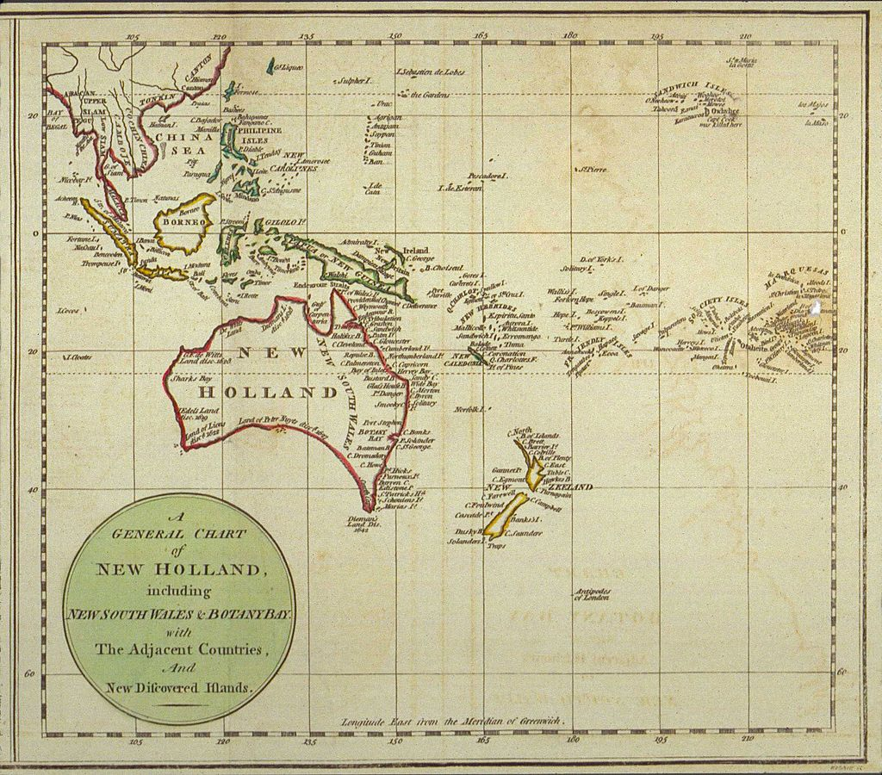
By [J. Stockdale] - A General Chart of New Holland including New South Wales & Botany Bay with The Adjacent Countries and New Discovered Lands, published in An Historical Narrative of the Discovery of New Holland and New South Wales, London, Fielding and Stockdale, November 1786., Public Domain, https://commons.wikimedia.org/w/index.php?curid=17588686

Robert O'Hara Burke (1820-1861) and William John Wills (1834-1861) were Australian explorers who were the first Europeans to cross Australia from south to north. They both died on the return trip, from exhaustion and hunger.
Burke and Wills were inexperienced explorers; Burke was a police investigator and Wills was a surveyor and meteorologist. Burke was chosen to lead the expedition across the inhospitable interior of Australia so that the state of Victoria could win the reward posted by the government of Australia for finding a north-south route. The government wanted to build a telegraph line from Adelaide to the northern coast of Australia

Edward John Eyre (1815-1901) was an English-born Australian explorer. With his aboriginal friend called Wylie, Eyre was the first European to walk across southern Australia from east to west (along the coast). This arduous trip took 4 1/2 months. They traveled from Adelaide to Albany, across the Nullarbor Plain. The expedition had begun with many men and pack horses, but harsh conditions and lack of food and water forced most of the men and the horses to turn back. Eyre and Wiley survived by using sponges to collect the morning dew, and eating kangaroos. Previously, Eyre had been on many shorter expeditions searching for good sheep-grazing land in southern Australia. An expedition to the center of Australia (from Adelaide) failed at Mt. Hopeless.

HUME, HAMILTON
Hamilton Hume (1797-1872) was an Australian explorer. Hume discovered Lake Bathurst when he was only 20 years old. Hume, together with William Hovell (an English sea captain) and six convicts, traveled overland through southeast Australia (the Berrima-Bong Bong District) to look for any large rivers. They set out in 1824 from Appin (where Hume lived) and traveled from Gunning to Corio Bay, discovering the Murray River, the Murrumbidgee River, and Mount Bland. They returned in 1825. Hume was rewarded with hundreds of acres of land

When he was only 17 years of age, Hume began exploring the country beyond Sydney with his younger brother John and an Aboriginal boy as far to the south-west as Berrima, and soon developed into a good bushman. In 1817, Hume went on a journey with James Meehan, the deputy surveyor-general, and Charles Throsby during which Lake Bathurst and the Goulburn Plains were sighted. Subsequently, in 1818, he went with John Oxley and Meehan to Jervis Bay.[3]
In 1822, he journeyed with Alexander Berry down the south coast of New South Wales. He travelled as far south as the Clyde River, and inland nearly as far as Braidwood. Berry came to settle in the Shoalhaven, and in June 1822 he left Hume and a party of convicts to cut a 209-yard canal between the Shoalhaven River and the Crookhaven River to allow passage of boats into the Shoalhaven. This canal was Australia's first navigable canal, and the work was completed in 12 days. The canal today forms the main water flow of the Shoalhaven River.



